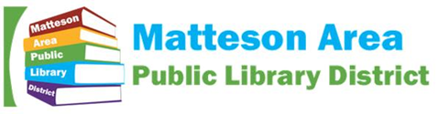

Agenda

Finance Committee Meeting
Wednesday, Dec. 13 at 10:30 AM
Room D
801 S. School Avenue
Matteson, Illinois, 60443

THIS MEETING IS OPEN TO THE PUBLIC
If you anticipate needing any type of accommodations or have questions about the physical access provided, please call (708) 748-4431 in advance of your participation or visit.

Items that are not listed on the agenda are for discussion only.

1. Call to Order

Our Mission: The library enables discovery, engages imagination, inspires innovation, and connects with our community.

Theme: Visioning as a Board the Library of the Future

2. Roll Call

3. Opportunity for Public Comment

4. Discussion with First American Bank

5. Other

6. Adjournment

